25th Sunday in Ordinary Time
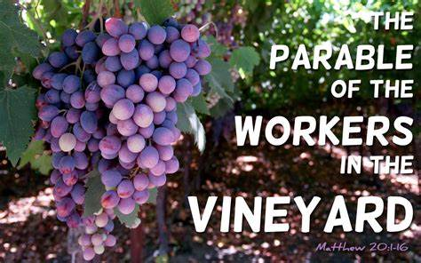

1st Reading: Isaiah 55:6-9
Turn to the Lord in urgent prayer; for he never ignores the prayer of the humble
Seek the Lord while he may be found, call upon him while he is near; let the wicked forsake their way, and the unrighteous their thoughts; let them return to the Lord, that he may have mercy on them, and to our God, for he will abundantly pardon. For my thoughts are not your thoughts, nor are your ways my ways, says the Lord. For as the heavens are higher than the earth, so are my ways higher than your ways and my thoughts than your thoughts.

Responsorial: Psalm 144:2-3, 8-9, 17-18
Response: The Lord is near to all who call him
I will bless you day after day
and praise your name for ever.
The Lord is great, highly to be praised,
his greatness cannot be measured. Resp:
The Lord is kind and full of compassion,
slow to anger, abounding in love.
How good is the Lord to all,
compassionate to all his creatures. Resp:
The Lord is just in all his ways
and loving in all his deeds.
He is close to all who call him,
who call on him from their hearts. Resp:
2nd Reading: Philippians 1:20-24, 27
Though Paul wants to be with Christ in heaven, he will serve the Gospel as long as God wills it
It is my eager expectation and hope that I will not be put to shame in any way, but that by my speaking with all boldness, Christ will be exalted now as always in my body, whether by life or by death. For to me, living is Christ and dying is gain. If I am to live in the flesh, that means fruitful labour for me; and I do not know which I prefer. I am hard pressed between the two: my desire is to depart and be with Christ, for that is far better; but to remain in the flesh is more necessary for you. Since I am convinced of this, I know that I will remain and continue with all of you for your progress and joy in faith, so that I may share abundantly in your boasting in Christ Jesus when I come to you again. Only, live your life in a manner worthy of the gospel of Christ, so that, whether I come and see you or am absent and hear about you, I will know that you are standing firm in one spirit, striving side by side with one mind for the faith of the gospel.
Gospel Acclamation:
Alleluia, Alleluia!
Open our hearts, O Lord,
To listen to the words of your Son
Alleluia!

Gospel: Matthew 20:1-16
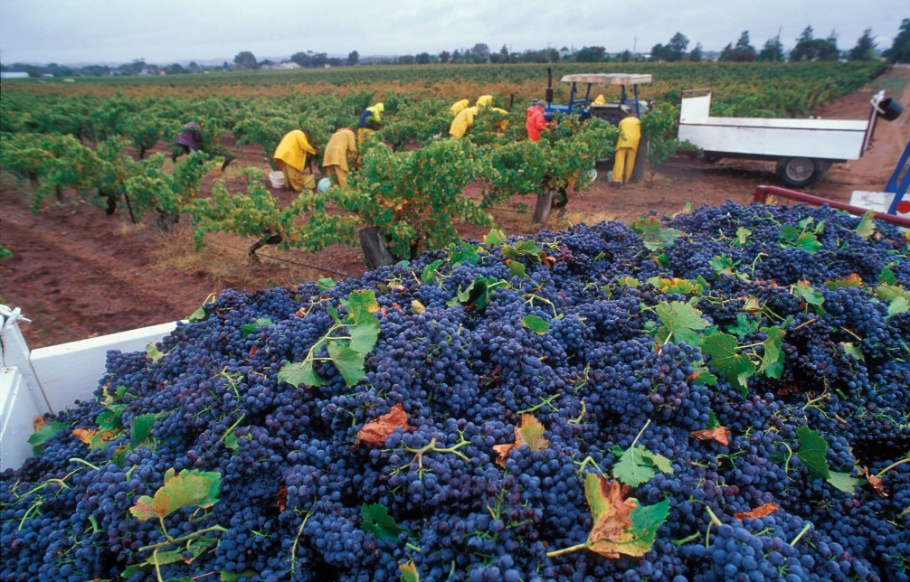
The parable of the workers in the vineyard; God welcomes all into his kingdom
Jesus said to his disciples: “For the kingdom of heaven is like a landowner who went out early in the morning to hire labourers for his vineyard. After agreeing with the labourers for the usual daily wage, he sent them into his vineyard. When he went out about nine o’clock, he saw others standing idle in the marketplace; and he said to them, “You also go into the vineyard, and I will pay you whatever is right.” So they went. When he went out again about noon and about three o’clock, he did the same. And about five o’clock he went out and found others standing around; and he said to them, “Why are you standing here idle all day?” They said to him, “Because no one has hired us.” He said to them, “You also go into the vineyard.’
When evening came, the owner of the vineyard said to his manager, “Call the labourers and give them their pay, beginning with the last and then going to the first.” When those hired about five o’clock came, each of them received the usual daily wage.
Now when the first came they thought they would receive more; but each of them also received the usual daily wage. And when they received it, they grumbled against the landowner, saying, “These last worked only one hour, and you have made them equal to us who have borne the burden of the day and the scorching heat.” But he replied to one of them, “Friend, I am doing you no wrong; did you not agree with me for the usual daily wage? Take what belongs to you and go; I choose to give to this last the same as I give to you. Am I not allowed to do what I choose with what belongs to me? Or are you envious because I am generous?” So the last will be first, and the first will be last.”

REFLECTIONS:
The core of the Gospel parable is also in the Isaiah passage: “My thoughts are not your thoughts.” Try as we may, it is impossible to justify the payment of the workers in the vineyard in ordinary social terms. It could hardly be said to be fair. Yes, the owner is generous to the last comers, but why is he not generous to the others as well? It is simply that there is no reckoning up deserts when man meets God.
In Our Lord’s time Judaism had reached a legalistic state, and the mentality was prevalent that salvation could and must be earned. There were many commands which must be fulfilled, and people were divided into two classes, the righteous who were on the road to salvation by fulfilling the commands, and the unrighteous, outcasts despised by those who kept the law. It was this slot-machine conception of God that Jesus opposed by his emphasis on love, for in love there is no calculation of duties, rights and obligations; there is only an open-handed giving without counting the cost, and a grateful receiving. We can never say that we have earned our salvation, or anything from God, but can only stand suppliant before him. The latest workers in the vine-yard have not earned what the owner gives them, and the mistake of their envious colleagues is to think that they can deserve well of the owner.
Devout Christians may find it hard to stomach that someone who repents on his deathbed is admitted to the kingdom no less than those who have struggled and suffered all their lives for what is right. But this would presuppose a commercial attitude of reward and punishments from God, and it neglects the nature of love. The relationship of the believer to God must be personal love, and as such it is its own reward, for it brings its own happiness also in this life. The greater the struggle, the more a Christian turns to God and finds comfort in the security of his love. Also, fidelity through a long life does bring some advantage over a skimpy final conversion, for it may well be that the relationship of love has so deepened over the years that the Christian, faithfully following Christ, has more capacity for the full enjoyment of God’s company than one who comes to know God only at the last moment. Here it is not a matter of God giving a greater reward, but of the person being more capable of receiving it.
Of this joyful relationship with God Paul was a shining example. While threatened with persecution he is filled with the joy of Christ. His life is already united with Christ’s life, and he longs for the fulfilment of final union.
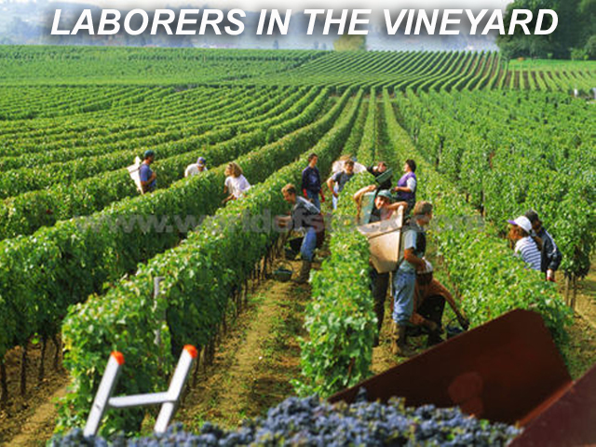
The parable of the vineyard-workers is no blueprint for labour relations, but it illustrates very well Jesus’ teaching about grace and mercy. There are consequences to be drawn, and, in The Joy of the Gospel, Pope Francis wrote: “The Church must be a place of mercy freely given, where everyone can feel welcomed, loved, forgiven and encouraged to live the good life of the Gospel.” (Paragraph/Section 114).

